Things to do this Easter in St Ives
Here in sunny St Ives and the surrounding area we have plenty to entertain our visitors over the Easter period. From days out Easter Egg hunting in the National Trust properties to learning all about the local birds and nesting on St Michaels Mount!

Bird Bonanza (St Michael’s Mount, March 30 to April 2)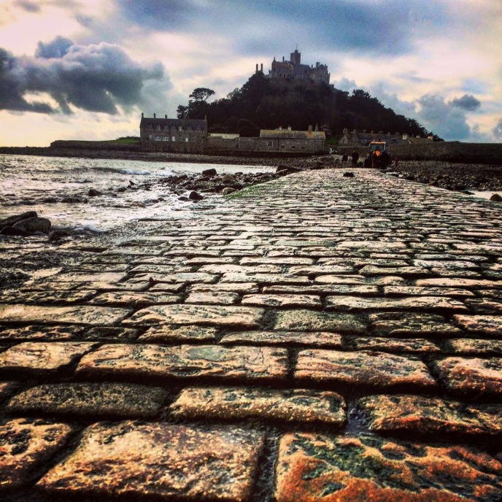
St Michael’s Mount is holding its first Bird Bonanza, where you can make your own willow bird feeder, plant a sunflower and become the best bird spotter. The birds are busy making their nests and with this free activity so can you as you have a go at making a birds nest. https://www.stmichaelsmount.co.uk/events/bird-bonanza-easter-weekend

Duck Race & Easter Egg Hunt, in St Erth
Every Good Friday afternoon the pretty village of St Erth holds an Easter Egg hunt followed by a Duck Race on the River through St Erth. This popular annual event will commence at 13:00 from St. Erth Church, entrance costs £1.50 and includes an Easter Egg.
For the under 8’s, a lucky child that finds the special Duck will Win £10 (Some eggs hold extra prizes), and for the under 12’s the child that uses the "clues" and finds the special Egg will Win £10!
The Duck Race race starts from the footbridge at the end of Green Lane at 14:00, entrance is £1 per duck. Tote boards are available for the ducks in St Erth Post Office/Store and The Star Inn.
The Star Inn will have a BBQ and a band playing in the beer garden at the back from 15:00.

Easter Fun at Eden (St Austell, March 24 to April 15)
With Easter Egg hunts, quests, an inflatable assault course and games, The Eden Project is full of many activities for all the family to have fun. With many different activities running through the Easter holidays be sure to head downthere while will the Easter Eggstravaganza is still on!
http://www.edenproject.com/visit/whats-on/easter

The National Trust Easter Egg Hunts
It's almost that time of the year when the National Trust teams up with Cadburys to offer the ultimate day out. Join them over the Easter holidays to run through muddy woodlands, around mystical lakes and along nature trails on a Cadbury Easter Egg Hunt 2018. https://www.nationaltrust.org.uk/lists/cadbury-egg-hunts-in-cornwall-

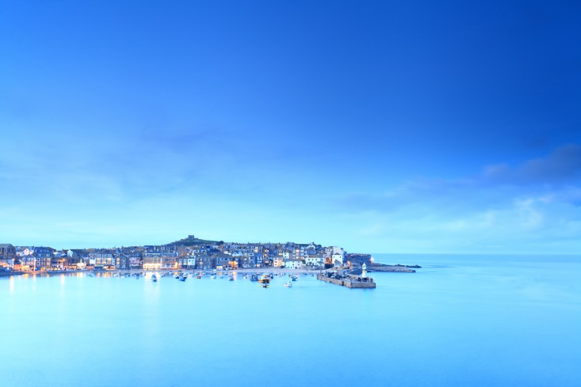
And if you don’t want to drive we have ‘events-a-plenty’ in St Ives itself, including:
A visit to The Leach Pottery who are running Easter weekend open days along with a Spring Seconds Sale of their fabulous pottery, a visit to The Tate, or, for the sweet toothed and chocoholics amongst you, Coco Kitchen are offering a bespoke Chocolate Workshop where you will have your own purpose-made work-space and tools to help you indulge and make your own delicious chocolates. If you are still peckish after this, grab something delicious from their café, selling Hot Chocolate, Ice Cream, Coffee, Milkshakes and Bakes.

And finally…..for a different experience - “The Man Engine Returns”
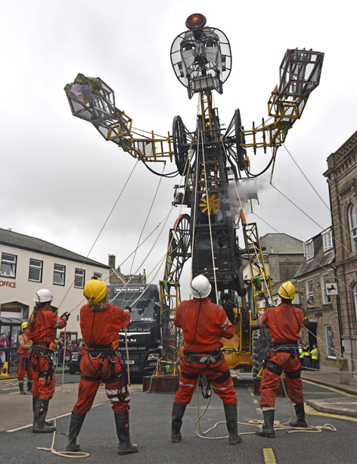
The largest mechanical puppet ever constructed in Britain toured the length of the Cornish Mining World Heritage Site last summer, unearthing a deep lode of passion and pride. Now, the colossal miner is preparing for his Resurrection Tour across Cornwall. On Saturday 31st March 2018, The Man Engine will re-appear where he was last seen at Geevor Tin Mine in West Penwith. He then heads east to Heartlands on Easter Sunday 1st April, with a visit to Cornwall’s ancient Stannary capital, Lostwithiel, on Easter Monday 2nd April.

Don’t Delay, Book Your Cherished Cottage Now!
If you are coming down to St Ives over the Easter Holidays make it special by staying in one of our luxurious Cherished Cottages for an Easter to remember. Please do not hesitate to give our friendly team a call in the office to make a reservation or for more information on 01736-490640.

